Virtual Testing Video Recording and Upload Instructions

PLEASE READ THIS DOCUMENT BEFORE FILMING AND UPLOADING FOR BEST RESULTS

*Note: This document was created by U.S. Figure Skating to ensure consistency and quality with videos being recorded for virtual test sessions.

Camera/Phone Specs/Setup
- Professional video cameras or cell phones with high-definition recording capability are acceptable.
  - If using a phone or tablet, film in landscape mode (turn the phone horizontally for a wide view).
- Videos are preferred to be shot in 1080p60 but must be a minimum of 720p60. Videos less than 720p60 will not be accepted for review.
  - To adjust video settings on an iPhone, go to Settings/Camera/Record Video
  - To adjust video settings on an Android Phone, go to Camera Apps/Settings Options Icon (Gear Icon)/Video Size
- Switch to Airplane Mode.
- Make sure there is enough space available on your phone to record. We recommend at least 2GB of available space.
- Clean your camera lens before you start recording.

Video Format
Video files have various formats that are indicated in the file title. This is automatically added when the video is created. MP4 files work best. If you have saved your file in another format, there could be some loss of resolution (blurry). WAV files are often low resolution and will result in an unclear picture. AVI files (often the default on a Mac computer) should be changed to MP4.

Recording Instructions
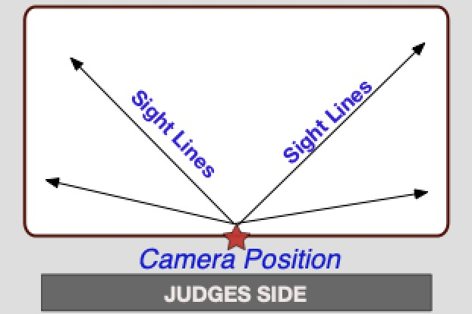
- Videographer should stand at center ice, with the camera elevated above the boards to capture all corners of the rink. Stand in a location to reduce obstructions as much as possible.

- If available, mount your phone on a tripod or steady mount. If handheld, the videographer should follow the athlete as smoothly as possible.

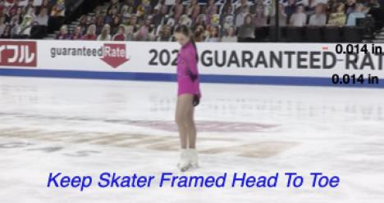
- Zoom in enough to have the skater fill a good amount of the screen but remain in focus. IMPORTANT: Keep the skater head to toe in the center of the screen (i.e. the frame) when following them during their performance.

- Record a test video, preferably a full run through of the performance to get comfortable with the flow of the program. Watch it back and see how the recording looks, and make any necessary adjustments accordingly for the final video.

- Include a date and time stamp at the beginning of the final video by holding up a phone in front of the camera that shows the date and time. Videos that do not include this will not be accepted.

- Announce the skater and test being performed or hold up a copy of the test paper prior to the start of the test.

- Make sure the music is loud enough for the officials to hear when they replay the videos during the judging process. We recommend you turn up the music when you record the program being skated on the ice.

- If you are recording a moves in the field test, make sure the audio is being recorded so the judges will be able to hear the skater’s edges.

- IMPORTANT: Keep frame clear of other skaters.

Video Upload Instructions

Deadline: We encourage you to complete your video and upload as soon as possible after you register. Videos cannot be accepted after the deadline regardless of circumstances.

REMINDER: Videos may only be uploaded one time and must be uploaded no later than the video submission deadline.

File Name: All files MUST be renamed to reflect the skater/team name, level and discipline. Each video should be titled with Skater First and Last Name, Level Event.

Example | Label (should match registration signup)
Solo Pattern Dance | Suzy Skater_Silver Solo Dance_Tango
Solo Pattern Dance – Adult | Suzy Skater_Silver Solo Dance_Tango_Adult21  Suzy Skater_Silver Solo Dance_Tango_Adult50
Partnered Pattern Dance – Standard | Suzy Skater_Silver Partnered Dance_Tango
Partnered Pattern Dance – Adult | Suzy Skater_Silver Partnered Dance_Tango_Adult21  Suzy Skater_Silver Partnered Dance_Tango_Adult50
Free Skate – Standard  Free Skate – Adult | Suzy Skater_Novice_Freeskate  Suzy Skater_Adult_Gold_Freeskate_Adult21  Suzy Skater_Adult_Gold_Freeskate_Adult50
Free Skate – Pairs | Cain-Leduc Senior_Pairs_Freeskate
Free Dance – Standard  Free Dance – Solo – Standard  Free Dance – Solo – Adult | Davis-White_Senior_Free_Dance  Suzy Skater_Solo_Senior_Free_Dance  Suzy Skater_Solo_Senior_Free_Dance_Adult21  Suzy Skater_Solo_Senior_Free_Dance_Adult50

Verification: The final submission by the athlete MUST be verified using the affidavit to be one continuous video and not edited to any extent. Video submissions will not contain any editing, splicing and must be recorded from one angle. Any videos that are deemed edited will be automatically revoked and refunds will not be issued.

Confirmation: After you upload your video per the instructions from the test chair, please send a confirmation email to the Test Chair testchair@centerskatingacademy.com and CC: your coach.

